SPLUNK GFG
Section 1: Splunk Theory
- What is Splunk?
In the modern age of computers, organizations produce huge quantities of machine data from networks, servers, applications, and security systems. Analyzing and managing such data manually is almost impossible, and hence Splunk plays its role.
Splunk is an effective tool for log management and data analytics that aids companies in collecting, analyzing, and visualizing machine-generated data in real-time. Splunk is extensively utilized for IT ops, cybersecurity, DevOps monitoring, and business analytics.
Splunk is an enterprise analytics platform built for real-time searching, monitoring, and analyzing machine data (such as logs)​. It operates by collecting and indexing data into a searchable index, from which graphs, reports, alerts, dashboards, and visualizations can be created by users​.
Splunk converts enormous amounts of raw IT data into actionable information, enabling the detection of patterns, resolution of issues, and business decision-making​. Companies apply Splunk to dissect data silos – even the name "Splunk" was derived from spelunking (cave exploration), as an analogy of digging deep into concealed data for value.
- History of Splunk:
Splunk was founded in 2003 by Michael Baum, Rob Das, and Erik Swan​. The founders were inspired by cave exploration (“spelunking”) as a metaphor for exploring the depths of IT data​. Early on, the product focused on a powerful search engine to scan and store IT log files, addressing the need to derive value from the “everything” that generates data in an organization. In 2023, Splunk marked its 20th anniversary and announced it would be acquired by Cisco for $28 billion, a deal completed in March 2024​.
- Why Organizations Use Splunk
Organizations adopt Splunk because it provides a unified way to handle diverse log and event data for multiple purposes. Splunk’s core value is turning machine data into insight – it helps IT operations teams quickly search and troubleshoot issues across complex infrastructures and helps security teams detect and investigate threats from a multitude of sources in one place​.
Unlike traditional tools, Splunk can ingest any text-based data (from servers, applications, network devices, sensors, etc.) and make it searchable and correlated. This versatility means Splunk can be used for everything from monitoring website performance to analysing user behaviour. Its flexibility as a “horizontal” technology (not limited to a single domain) allows use cases in application management, cybersecurity, compliance auditing, web analytics, business intelligence and more. In practice, companies have found that using Splunk leads to improved system uptime (thanks to faster problem resolution), reduced operational costs through automation of log analysis, stronger security postures via real-time alerting, and better compliance reporting​.
- Core Features of Splunk
- Data Ingestion, Indexing and Search:
Splunk can collect data from practically any source or format – logs, metrics, events, configurations, etc. – regardless of where it is coming from servers, network devices, applications, cloud services, or databases. In ingestion, Splunk’s indexing engine processes the raw data into searchable events, adding the timestamps and also add the metadata (like host, source, source type) to each event​
This indexing allows extremely fast search and retrieval the huge data sets. Users can also query the data using the Splunk’s Search Processing Language (SPL) it is a powerful query language in splunk that supports statistics, filtering, and formatting. The search capability is a cornerstone of Splunk: through simple keywords or complex SPL queries, users can quickly locate specific logs, correlate events from different sources, and extract meaningful information
- Log Management and Analysis
At its heart, Splunk is often used as a central log management system. Splunk continuously collects and aggregates logs from the distributed systems into one place. Splunk then provides tools to analyze these logs for operational intelligence. It can also parse raw text logs into structured fields and also apply transformations (like masking sensitive data or discarding unwanted events) and perform real-time analysis on the log data.
For example, finding all the errors in any events in a given timeframe or we can create scheduled searches that look for the patterns like a spike in 500-error codes. Splunk also supports statistical analysis of logs (through commands like stats or timechart in SPL) to derive metrics and trends from qualitative log data. This turns unstructured logs into valuable analytics such as error rate over time, user activity trends, or frequency of specific messages
- Real-Time Monitoring and Alerting
Splunk excels not only at retrospective analysis but also at real-time data monitoring. As data is ingested and indexed, Splunk can continuously evaluate it against conditions or thresholds you define. Searches can be scheduled to run on a regular interval or even set to run in real-time, updating as new events stream in.
Based on these searches, Splunk can trigger alerts when certain criteria are met – for instance, if a specific error message appears, if the number of failed login attempts exceeds a threshold in a 5-minute window, or if a server’s CPU usage stays above 90% for too long. Alerts can be delivered through various channels (email, SMS, creating a ServiceNow ticket, executing a script, etc.). This real-time alerting capability means Splunk can function as a monitoring system for IT operations and security.
- Dashboards and Visualization
To make sense of large data sets, Splunk offers robust visualization and reporting features. Users can build interactive dashboards that display charts, graphs, tables, maps, and other visualizations reflecting the data in Splunk​. These dashboards are highly customizable – you can create panels for different metrics (e.g., a line chart of website response times, a pie chart of log severity levels, a single value showing the count of active alerts, etc.)
Splunk also provides many out-of-the-box reports and the ability to generate PDF reports on a schedule. This visualization capability turns raw data into at-a-glance insights for technical and non-technical audiences alike.
- Security and Threat Detection Features
Splunk has evolved into a leading platform for security information and event management (SIEM). It includes features specifically aimed at security analysis: the ability to ingest data from security devices (firewalls, IDS/IPS, antivirus, etc.), perform correlation across disparate data sources, and detect anomalies or known threat patterns.
Splunk also provides access controls and audit capabilities to ensure security of the data it stores: data can be encrypted in transit and at rest, role-based access can restrict what certain users can search or see, and all user activity in Splunk can be audited​
- Integration with Third-Party Tools
Splunk is designed to be extensible and to fit into a larger ecosystem of IT and DevOps tools. It provides a wide range of integrations and open interfaces. Splunk can ingest data from message queues, APIs, databases, and applications; it supports standards like syslog, and can receive data via HTTP (using the HTTP Event Collector) for custom integrations.
for example, ingesting AWS CloudWatch logs, or pulling data from Kubernetes, or integrating with Salesforce. Splunk also offers an SDK and REST API, so developers can programmatically search data or manage the platform from external scripts and applications.

- Use Cases of Splunk:
- IT Operations Monitoring: Splunk is widely used by IT operations and DevOps teams to monitor the health and performance of infrastructure and applications. By aggregating logs and metrics from servers, network gear, operating systems, databases, and cloud services, Splunk gives a unified real-time view of an organization’s tech stack.
- Cybersecurity and Threat Intelligence: One of Splunk’s strongest domains is cybersecurity. Security Operations Center (SOC) teams leverage Splunk as their SIEM platform to collect and correlate security-relevant data: firewall logs, intrusion detection alerts, endpoint logs, authentication events, etc. Splunk can continuously monitor for threat indicators (e.g., multiple failed logins, traffic to known malicious domains) and generate alerts for analysts
- Compliance and Auditing: Many organizations have compliance requirements (PCI-DSS, HIPAA, GDPR, SOX, etc.) that mandate logging of certain activities and regular reporting. Splunk is often used to meet these needs.
- Application Performance Monitoring (APM): Developers and site reliability engineers use Splunk to ensure applications are performing well and to troubleshoot issues in the software stack. While Splunk isn’t an APM tool in the traditional sense, it becomes one by analyzing application logs and metrics
- Splunk Architecture:
Splunk’s architecture is modular and scalable, consisting of several key components that work together in a data pipeline. The primary components are forwarders, indexers, and search heads, with additional supporting roles for management and coordination.
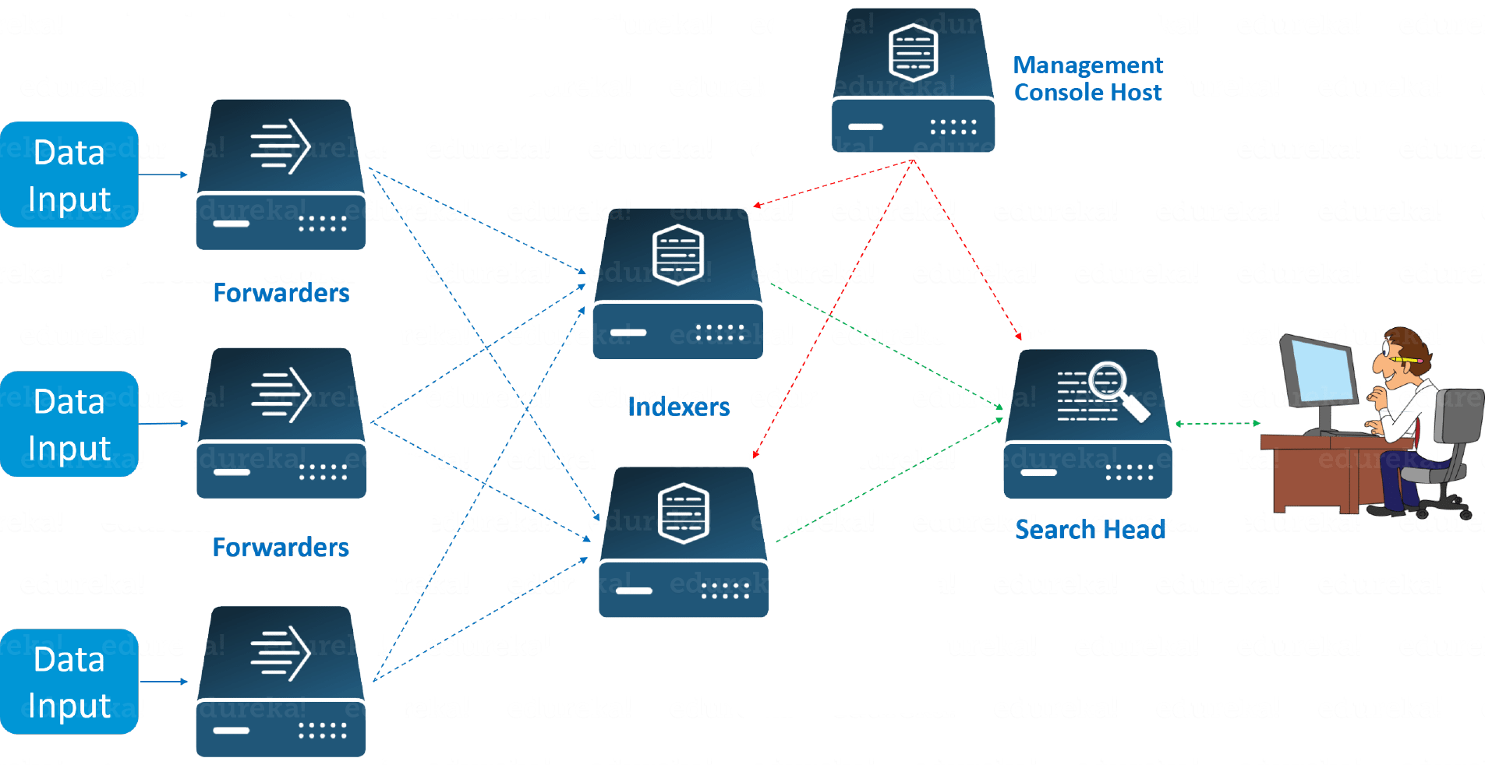
1. Forwarder
A Splunk Forwarder is a lightweight agent installed on source systems (servers, network devices, applications) to collect data and send it to the Splunk indexer. Forwarders continuously monitor specified log files, system metrics, network ports, etc., and forward that data to the indexing layer. There are two types of forwarders in Splunk: the Universal Forwarder (UF) which simply sends raw data as is (with minimal overhead), and the Heavy Forwarder (HF) which can parse and preprocess data before sending
2. Indexer
The Splunk Indexer is the heart of the Splunk architecture – it receives raw data (from forwarders or other inputs), processes it, and stores it as searchable events in indexes. When data arrives at an indexer, it goes through parsing (if not already done by a heavy forwarder): breaking the stream into individual events, identifying timestamps, extracting default fields (host, source, sourcetype), and applying transformations (like dropping debug events or masking fields as configured)​. After parsing, the indexer writes the data to disk in a structured way: it stores the raw data (usually compressed) and builds index files (often called tsidx files) that map keywords/terms to locations in the raw data
3. Search Head
The Splunk Search Head is the component that provides the user interface (web or CLI) for users to search and analyze data. It accepts search requests from users (for example, a query string in SPL) and distributes those searches to the indexers which contain the data​
4. Other Components
Splunk Enterprise includes additional components for management and coordination. A Deployment Server is a Splunk instance (often the same as a search head or a dedicated node) that centrally manages configuration for other Splunk instances.
A License Master (or license manager) is responsible for managing Splunk license usage. Splunk’s traditional license is based on the volume of data indexed per day, and a license master ensures that all indexers stay within licensed limits, pooling the quota across a deployment. It will disable searching if the license is grossly violated.
In clustered environments, there may also be a Cluster Master node (for indexer clusters) and a Deployer (to push configs to search head clusters)
- Installation and Setup of Splunk:
Install Splunk in Linux:
1. You can install Splunk via a tarball (.tgz) or package (.rpm/.deb) from its official website
2. In a typical Linux installation using the tarball, you would add the “splunk” user, extract the Splunk tar.gz to /opt/splunk then run
/opt/splunk/bin/splunk start
3. Set up admin credentials when prompted. For example:
/opt/splunk/bin/splunk edit user admin -password <your_password> -role admin -auth admin:changeme
4. Splunk runs a web server on port 8000 – you can then log into the Splunk Web UI via a browser.
http://localhost:8000
Install Splunk in RedHat/CentOS:
1. Download the Splunk RPM package from the official Splunk website.
2. Open the terminal and navigate to the directory where the RPM file is downloaded.
3. Run the following command to install Splunk:
sudo rpm -i splunk-package-name.rpm
4. Start Splunk by running
/opt/splunk/bin/splunk start
5. Set up admin credentials when prompted. For example:
/opt/splunk/bin/splunk edit user admin -password <your_password> -role admin -auth admin:changeme
6. Access Splunk Web by opening your browser and navigating to
http://localhost:8000\

- Advantages of Splunk:
Schema-on-Read Flexibility: Ingests any data type without needing a rigid, predefined structure, applying structure only when you search it.
Real-Time Data Processing: Provides immediate insights by processing and analyzing data as soon as it's ingested.
Exceptional Scalability: Handles petabytes of data and scales easily to meet the demands of enterprise-level operations.
Powerful Search Language (SPL): The proprietary Search Processing Language allows for complex queries, correlations, and data manipulation.
Universal Data Collection: Uses lightweight agents (Universal Forwarders) to efficiently collect data from virtually any source across any environment.
Comprehensive Data Correlation: Connects and correlates events and metrics from disparate sources for deeper analysis and root cause identification.
Robust Security Monitoring (SIEM): Excels at real-time threat detection, investigation, and compliance reporting across all logs.
IT Operations & Observability: Offers full-stack visibility into infrastructure, applications, and user experience for faster troubleshooting.
Machine Learning Integration: Built-in tools allow for advanced analytics, predictive modeling, and automated anomaly detection.
Customizable Dashboards: Enables the creation of interactive, real-time visualizations to monitor key performance indicators (KPIs) and system health.
Extensive App Ecosystem: Provides thousands of pre-built applications and add-ons to extend functionality for specific use cases and technologies.

- Disadvantages of Splunk:
High Licensing Cost: The pricing, often based on data ingestion volume, can become prohibitively expensive as data grows.
Steep Learning Curve: Mastery of the proprietary Search Processing Language (SPL) and advanced architecture requires significant time and expertise.
Resource-Intensive: Requires substantial computational power (CPU, RAM, storage) for indexing, searching, and maintaining large datasets.
Complex Deployment & Management: Setting up and managing large, distributed, high-availability deployments requires specialized knowledge and dedicated administration.
Data Retention Challenges: Keeping historical data searchable for long periods can be very costly due to the indexed storage requirements.
UI/Visualization Limitations: The built-in dashboard and visualization options, while functional, can be less flexible or visually modern than dedicated BI tools.
Vendor Lock-in: Reliance on the proprietary SPL and data format makes migrating to a different platform difficult and costly.

- Splunk vs ELK Stack vs Sumo Logic



